+
DORDON PARISH COUNCIL

PLEASE NOTE:

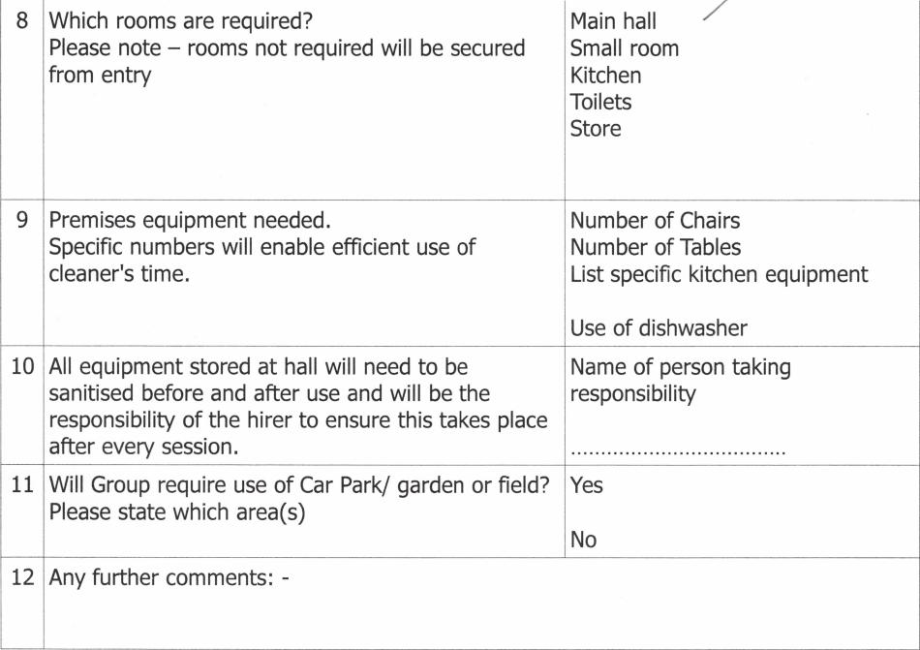
8
Which rooms are required?
Please note — rooms not required will be secured from entry
9
Premises equipment needed.
Specific numbers will enable efficient use of cleaner's time.
10
All equipment stored at hall will need to be sanitised before and after use and will be the responsibility of the hirer to ensure this takes place after every session.
Yes
No
11 Will Group require use of Car Park/ garden or field?
Please state which area(s)
12 Any further comments: -
Main hall Small room Kitchen Toilets Store
Number of Chairs
Number of Tables
List specific kitchen equipment
Use of dishwasher
Name of person taking responsibility
- The hall will be cleaned once per day by the hall cleaner. The hiring group will be responsible for cleaning surfaces used regularly during and at the end of hire. Sanitiser or soap and water will be available on entry and exit to the hall
- The hall will have a weekly deep clean.
- Access will only be allowed during the specific time of hire.
- Persons waiting to collect hall users should adhere to social distancing at front of building or remain in vehicle.
- A group risk assessment will be required for hall usage.
- All groups will need their own insurance cover for hire in case of a coronavirus outbreak.
- Isolation facilities will be available in [the meeting room] at back of hall.
- The hire charge of the hall will remain the same as before the outbreak for a period of [ weeks]. All organisations and groups will be given due warning of any increase.
To comply with Government advice, the Village Hall Trustees wish to ensure all users can be guaranteed a safe and sanitised environment in which to return and access our facilities. A risk assessment will be available but may be subject to change at any time in line with Government and Village Hall Guidelines.
Page 2 of 3
grore 3neet
⁷
: aninr yot"
vage hail after lockdown

